# Multi Branch Pipelines

While creating pipeline select ‘Multibranch pipeline’ project. This project sets individual pipeline for each branch and keeps scanning repo periodically.

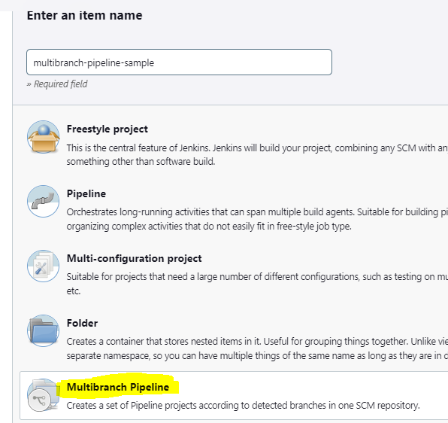

Periodic scanning is usually 2 mins (famous setting) to see if new branch is created and create new pipeline for new branch.

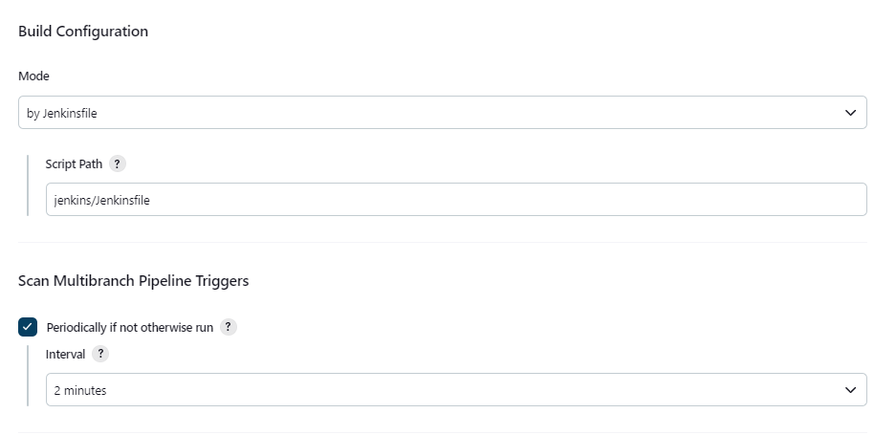

It creates separate pipeline for each branch which can be executed separately and give different results depending ion things configure in its respective jenkinsfile.

